Greenbrier Rail Services



Weekly Backlog Report Requirements – v1.0 – 3/26/2010

# Overview

Each week, Greenbrier Rail Services (GRS) repair locations report their work backlogs and other key operational measurements. GRS is seeking to standardize and automate the data collection for this activity. A conceptual prototype of a data entry form to collect the required data elements is illustrated in the figure below.

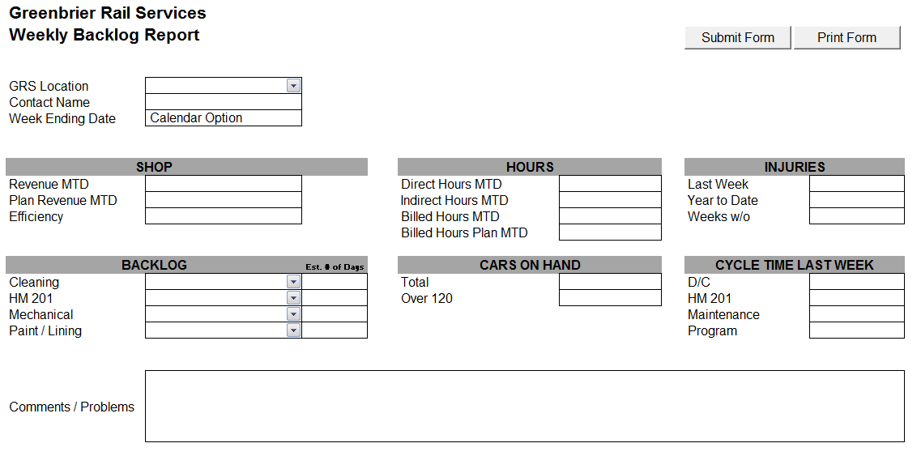

Figure : Prototype Weekly Backlog Report Form

There are two data entry forms required for this project, one to collect the weekly backlog data and one to specify the monthly planned revenue and billed hours for each location.

# Weekly Backlog Data Entry Form

Each GRS repair location will complete a report at the start of each week. This form must capture the following data attribute values:

* GRS Location
  + Value is selected from a drop-down list
* Contact Name
  + Value is display-only; derived from the GRS Location specified
* Week-Ending Date
  + Value must be a valid Friday date
* Revenue MTD – numeric value
* Plan Revenue MTD
  + Calculated, no input permitted
  + Value is derived based a prorated amount of the Plan Revenue for the month based on the Week-Ending Date and GRS Location attribute values
    - **Algorithm** = Plan Revenue for the month x (Number of business days MTD ÷ Number of business days in the month)
* Efficiency – numeric value
* Cleaning Backlog
  + Value is selected from a drop-down list; valid values are ‘Excellent’, ‘Very Good’, ‘Good’, ‘Poor’, ‘Very Poor’ & ‘N/A’
* Cleaning Backlog Estimated Number of Days – numeric value
* HM 201 Backlog
  + Value is selected from a drop-down list; valid values are ‘Excellent’, ‘Very Good’, ‘Good’, ‘Poor’, ‘Very Poor’ & ‘N/A’
* HM 201 Backlog Estimated Number of Days – numeric value
* Mechanical Backlog
  + Value is selected from a drop-down list; valid values are ‘Excellent’, ‘Very Good’, ‘Good’, ‘Poor’, ‘Very Poor’ & ‘N/A’
* Mechanical Backlog Estimated Number of Days – numeric value
* Paint/Lining Backlog
  + Value is selected from a drop-down list; valid values are ‘Excellent’, ‘Very Good’, ‘Good’, ‘Poor’, ‘Very Poor’ & ‘N/A’
* Paint/Lining Backlog Estimated Number of Days – numeric value
* Direct Hours MTD – integer value
* Indirect Hours MTD – integer value
* Billed Hours MTD – integer value
* Billed Hours Plan MTD
  + Calculated, no input permitted
  + Value is derived based a prorated amount of the Plan Billed Hours for the month based on the Week-Ending Date and GRS Location attribute value
    - **Algorithm** = Plan Billed Hours for the month x (Number of business days MTD ÷ Number of business days in the month)
* Total Cars On Hand – integer value
* Over 120 Cars On Hand – integer value
* Injuries Last Week – integer value
* Injuries Year To Date – integer value
* Weeks Without an Injury – integer value
* Previous Week D/C Cycle Time – numeric value
* Previous Week HM 201 Cycle Time – numeric value
* Previous Week Maintenance Cycle Time – numeric value
* Previous Week Program Cycle Time – numeric value
* Comments – Free-form text value

# Monthly Plan Data Entry Form

This form will be used only GRS financial individuals on a periodic basis. This form must capture the following data attribute values:

* GRS Location
* Month/Period
* Plan Revenue
* Plan Billed Hours

There can only be one record per GRS Location and Month/Period.

# Miscellaneous Requirements

## Monthly Working Calendar

Each Location may have different monthly working calendar; this calendar does not necessarily align with the nominal monthly calendar. This will affect the calculations of the Plan Revenue MTD and Billed Hours Plan MTD attributes.

## Reporting Requirements

For the initial release, there are no formal reporting requirements, although access in some form to the underlying data is desired. Time and budget permitting, formal reports permitting an individual locations and time periods would be useful.

## Authentication/Security Requirements

For the initial release, there are no formal authentication or other security requirements.